 GALGOTIAS UNIVERSITY  
 PLOT NO.2, SECTOR – 17 A, YAMUNA EXPRESSWAY,  
 GREATER NOIDA, GAUTAM BUDH NAGAR, U.P INDIA

SCHOOL OF COMPUTING SCIENCE AND ENGINEERING

SUBJECT :SCI LAB PROGRAMME :B.Tech

Subject code : BCS01T1001 Semester :1st

Submitted to :

Mr. VISHAL KUMAR

Submitted By :

ABHINAV KUMAR CHOUDHARY(21SCSE1011615)

Section : 24 (P1)

|  |  |
| --- | --- |
| **S. No.** | **List of Experiments** |
| 1. | Overview, Basic syntax, Mathematical Operators, Predefined constants, Built in functions at **SCILAB** platform. |
| 2. | Write a **SCILAB** code to find addition, subtraction, multiplication and division of two matrices , transpose of a matrix and inverse of a non singular matrix. |
| 3. | Write a SCILAB code for programming -Functions - Loops - Conditional statements - Handling .sci files. |
| 4. | Write a SCILAB code for 2-D : circle, parabola, ellipse and hyperbola and 3-D surfaces: Planes, Sphere, Cylinder, Paraboloid, Ellipsoid, Hyperboloid, cone. |
| 5. | Write a **SCILAB** code to find expansion of functions in Taylor series. |
| 6. | Write a **SCILAB** code for Fourier series expansion of different wave forms and comparison with the original function. |

EXPERIMENT - 1

1.Compute:

(i)7+8/2 (ii) (7+8)/2 (iii) ( 4+2X5)/7

2. Evaluate:

(i) 271/3+ 320.2 (ii) √ 64+ e4 (iii)sin𝛑/6+cos60

|  |  |  |
| --- | --- | --- |
|  |  |  |
|  |  |  |
|  |  |  |

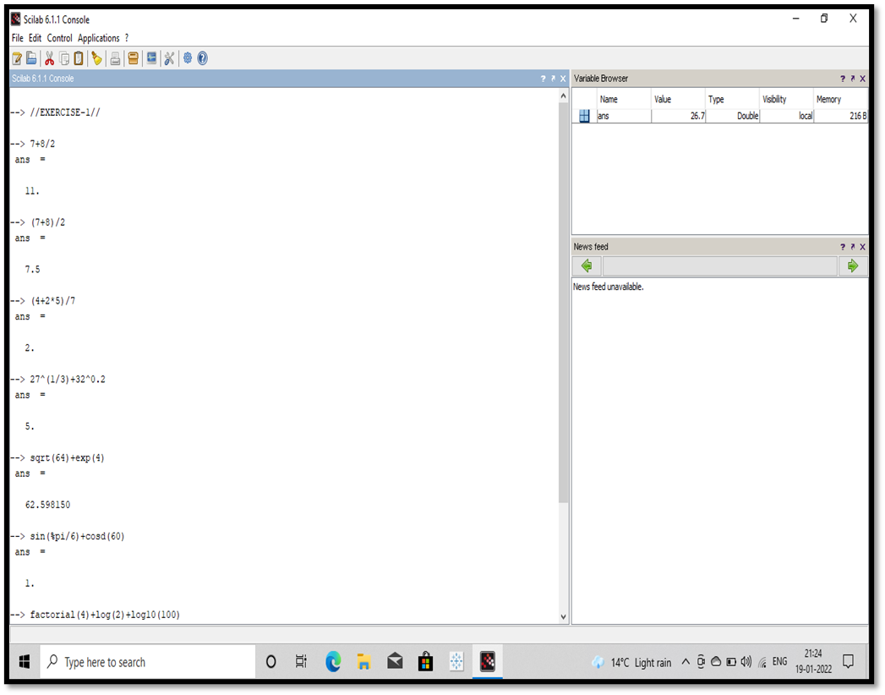

*(iv) 4!+ln2+log100 (v) (2+3i)(4+5i)*

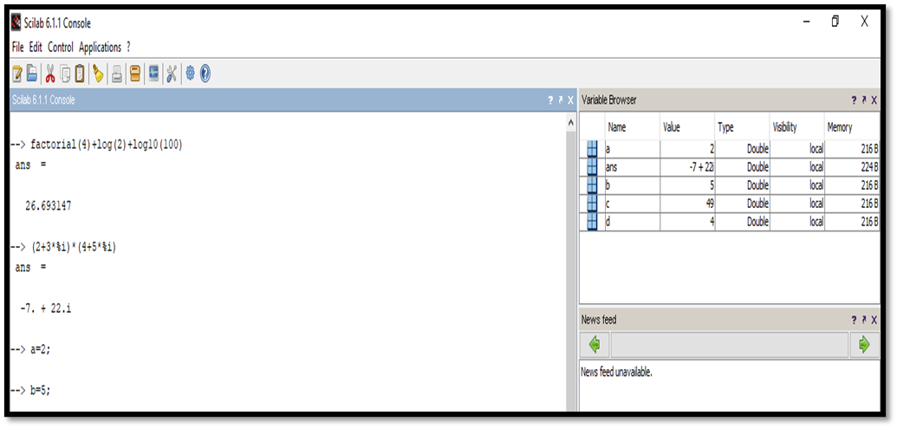

*2. By assigning values 2 and 5 to variables a and b respectively, compute*

*(i) c=(a+b)2 (ii) d=4a-3b+lna+ c2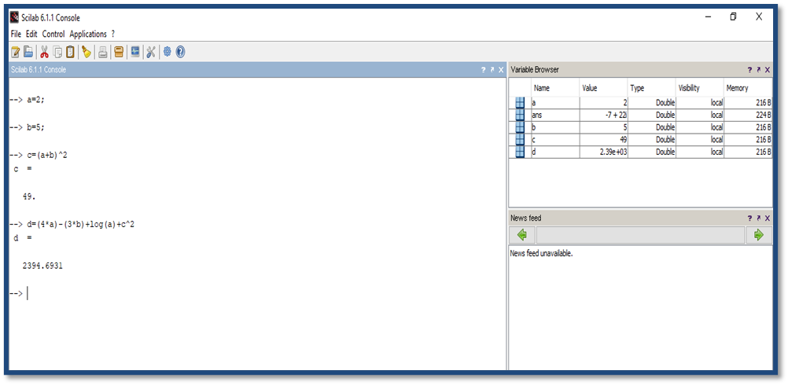*

3.Write the script file for the problem:

The radius of a circle is 2cm. Find its area.

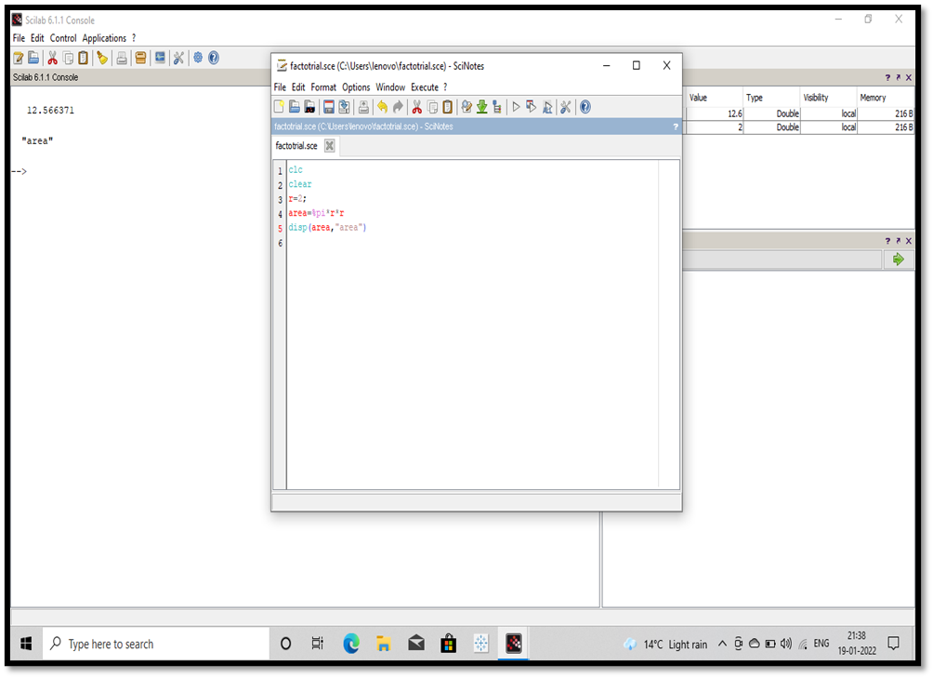

***EXERCISE 2***

***To write a Scilab code to find the solution of following problems:***

***1. (i) create a row vector with 3 elements.***

***(ii) create a column vector with 4 elements***

***2. By taking first term a=1 and the last term b=10 create a one dimensional array :***

***(i) by taking the spacing between two consecutive terms d=2 ,***

***(ii) by taking the number of terms n= 12***

***3. Create two row vectors (1dimensional arrays) a and b such that the following operations are defined and hence find :***

***(i) 2a-3b, (ii)2(transpose a)-3(transpose b)***

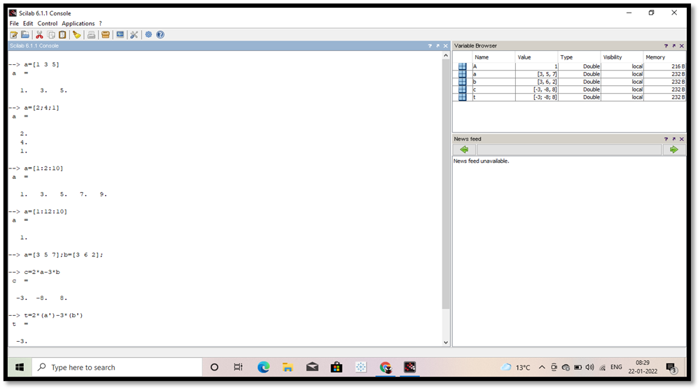

***4. Create two matrices( two dimensional arrays)A and B such that the following operations are defined and hence :***

***(i) 3A-AB2***

***5. Create a matrix A so that the following operations are defined and find:***

***(i) determinant of A, (ii) Inverse of A, (iii) product of A and inverse of A***

***6.Find the root :-x2-x-2=0***

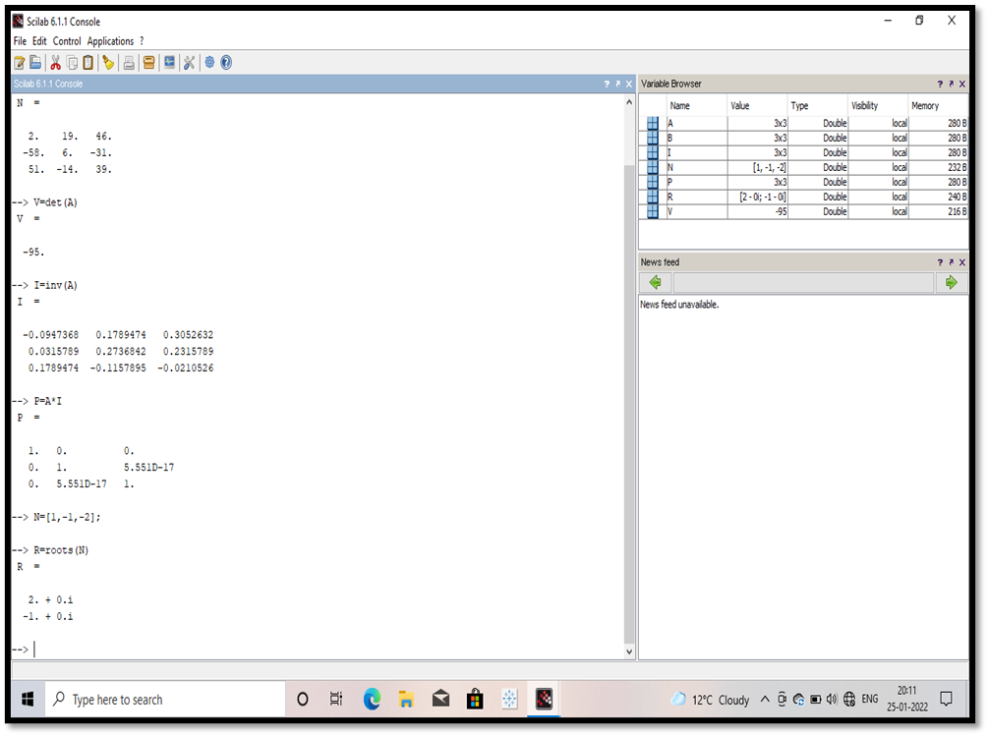

EXERCISE 3

1.To find volume and curve surface area of cone using input function.

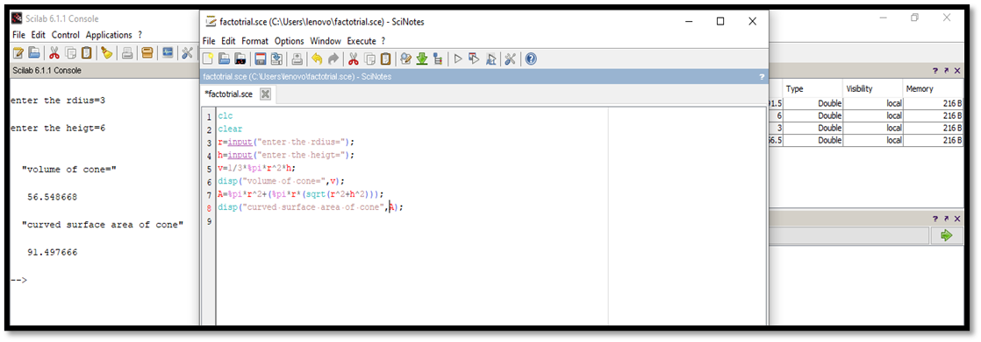

2. To find whether an integer entered by user is odd or even, using if- else-end command

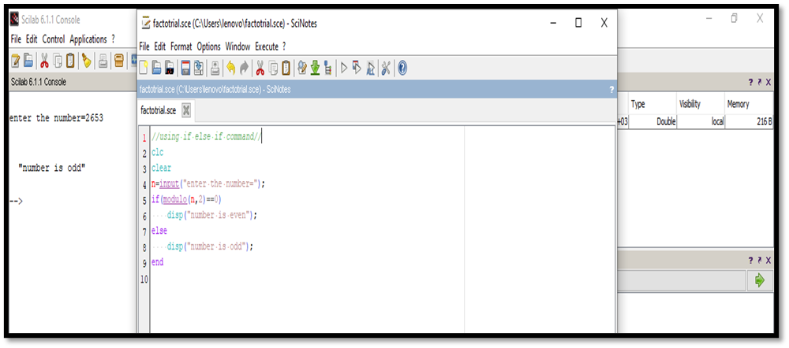*3. To find whether a real number entered by user is negative, zero or a positive using if- elseif-else-end command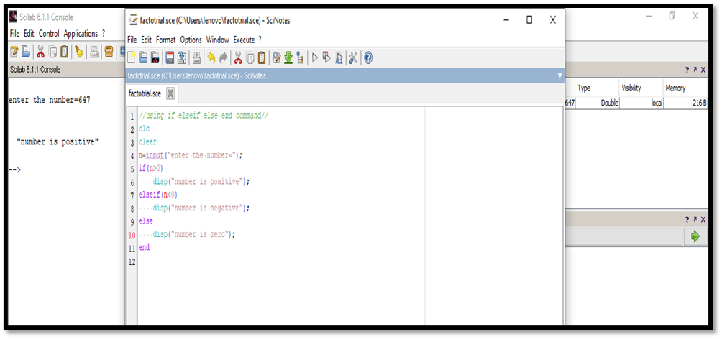*

*4. To find the sum of first n natural numbers using for loop*

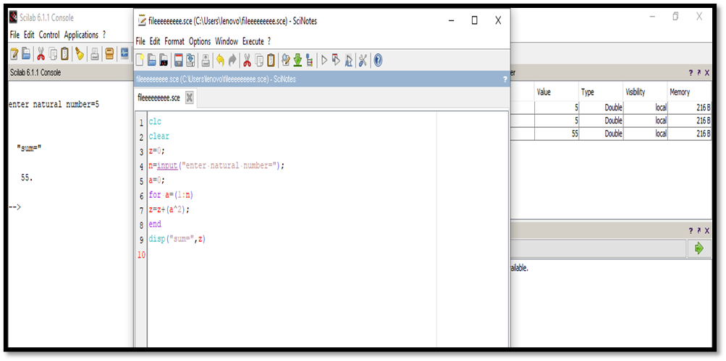

*5 . To find the sum of first n natural numbers, using while loop.*

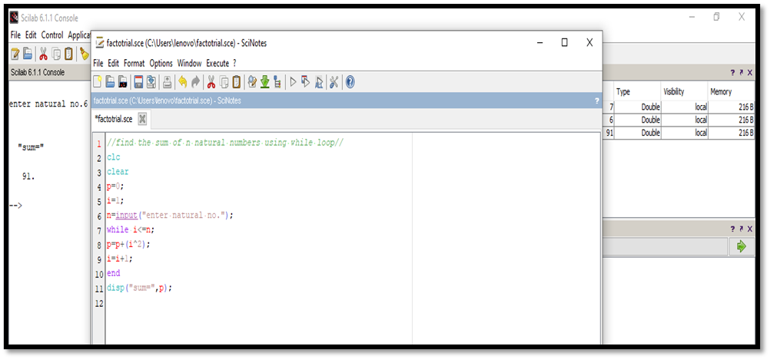

*6. To find factorial of a number using for loop*

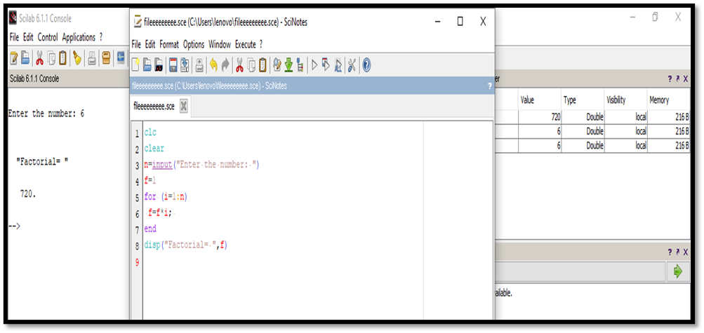

*7. To find factorial of a number using while loop*

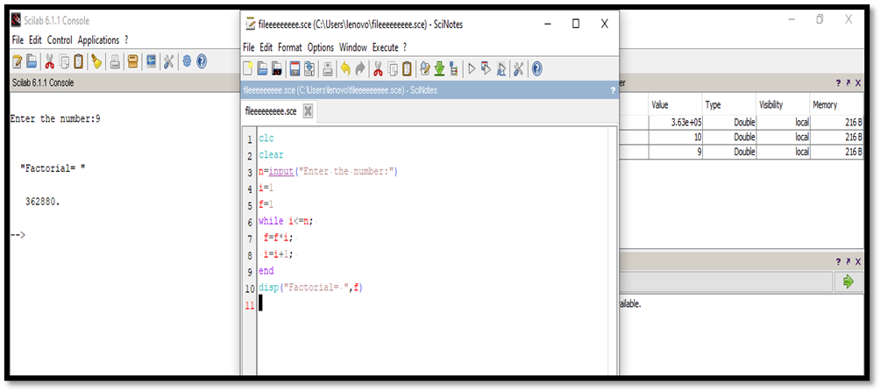

*8. To find first 20 terms of Fibonacci sequence using for loop*

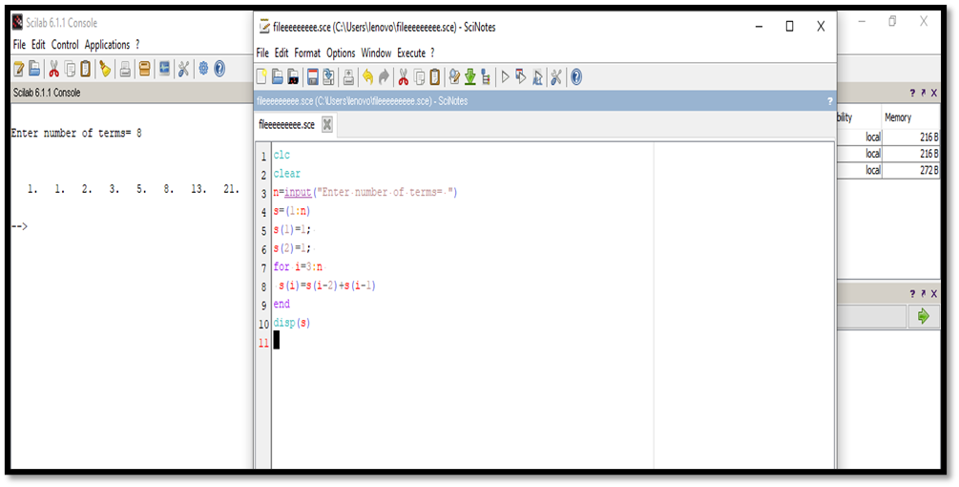

*9. To find volume and total surface area of a cylinder using user defined function*

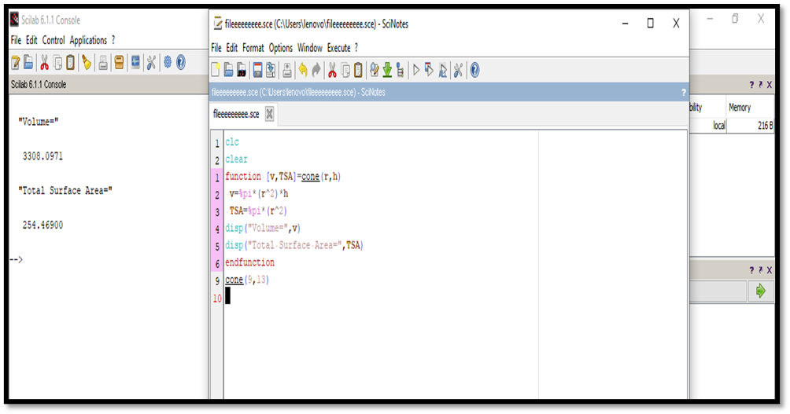

*EXERCISE 4*

*Write a Scilab code in a script file:*

*1. To plot Parabola x2=4ay. Take focal length a=1*

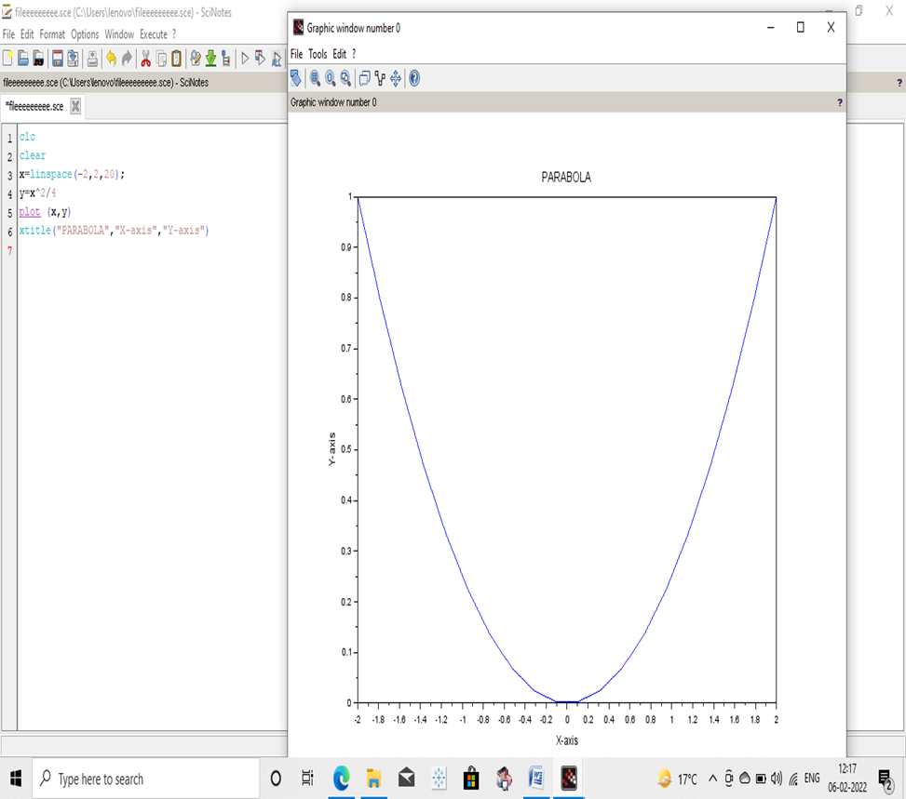

***2. To plot Circle. X2+y2=a2 ,t ake a=1***

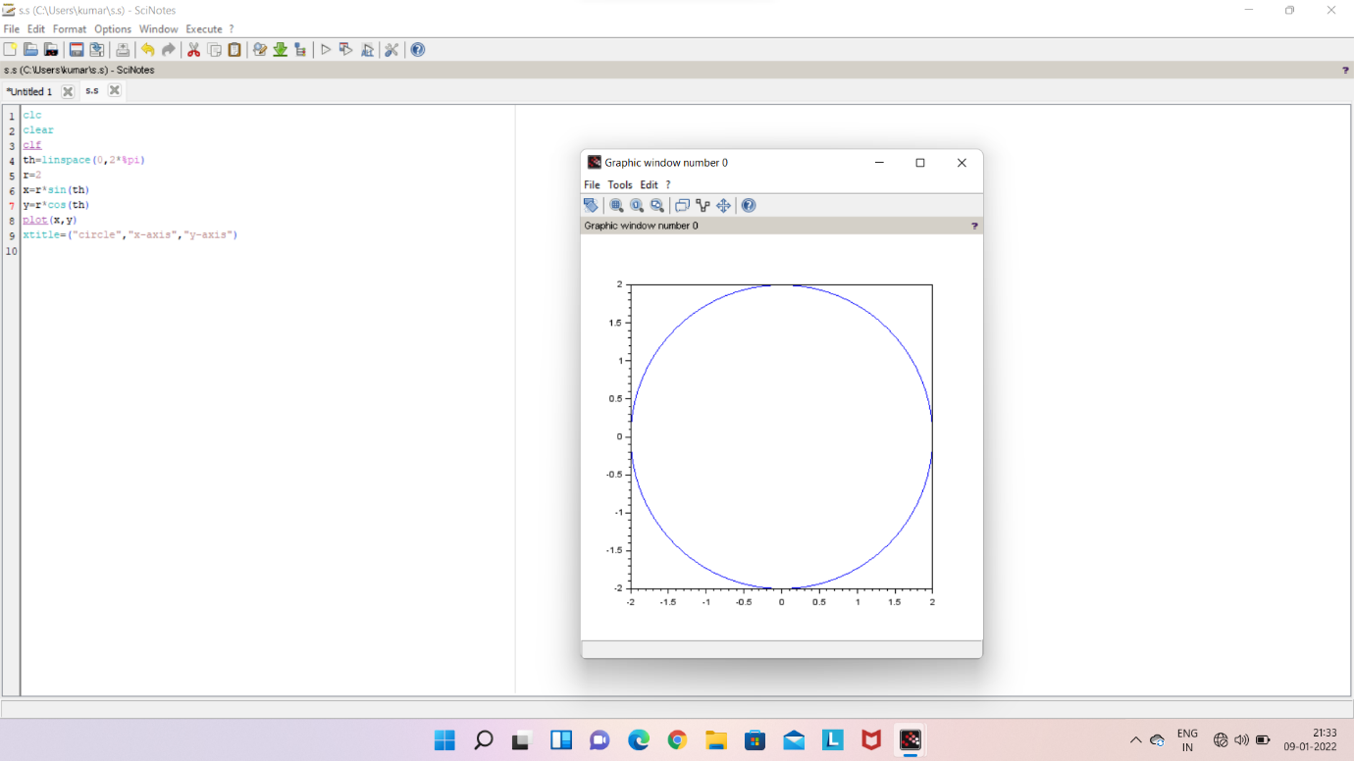

*3. To plot Ellipse. X2/ a2 + y2/ b2 =1. Take a=4,b=3*

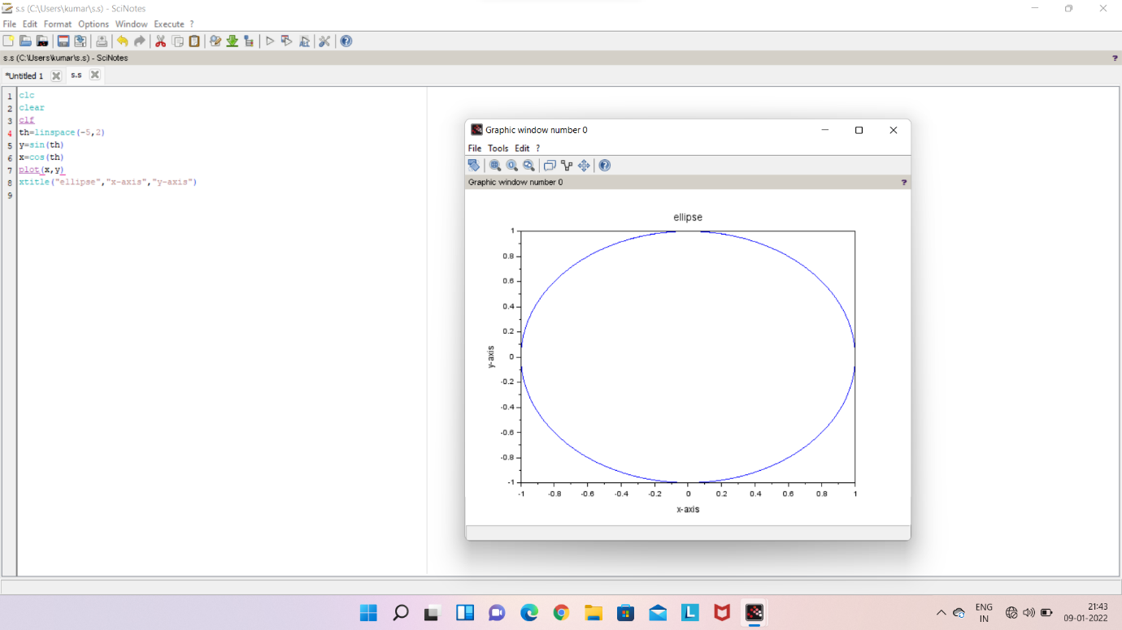

*4. To plot Hyperbola. X2/ a2- y2/ b2 =1 , Take a=3, b=4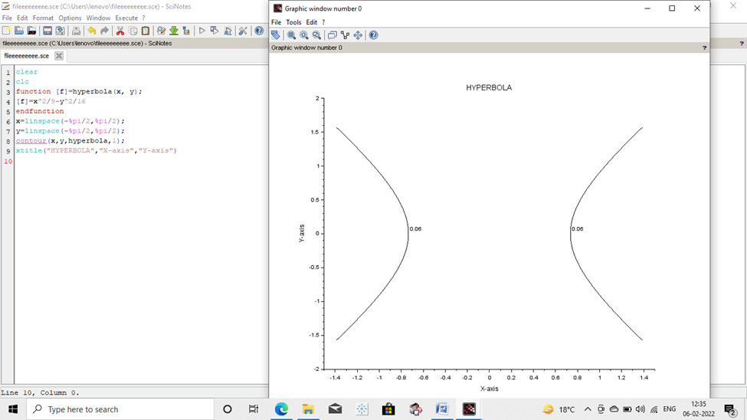*

*5. To plot a Plane ax+ by +cz=d take a=b=-1,c=1,d=4 z=4+x+y*

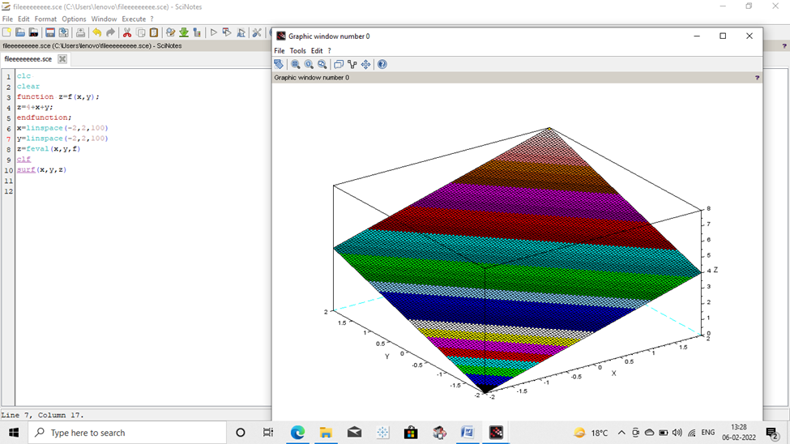

*6. To plot rectangular parabola xy=1 in interval[0.5,2]*

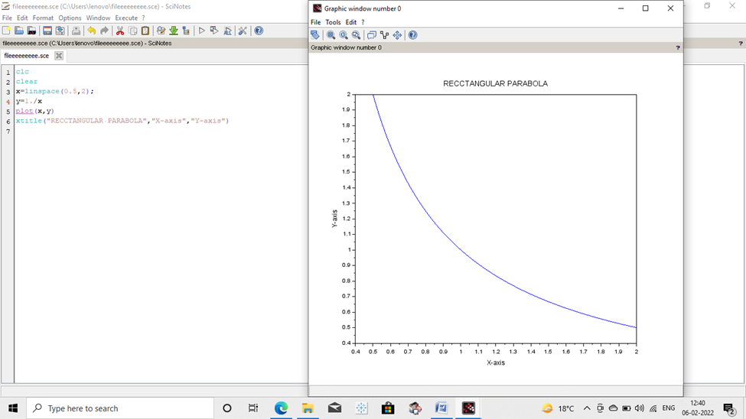

*7. To plot right circular Cylinder. x2+y2=a2****.***

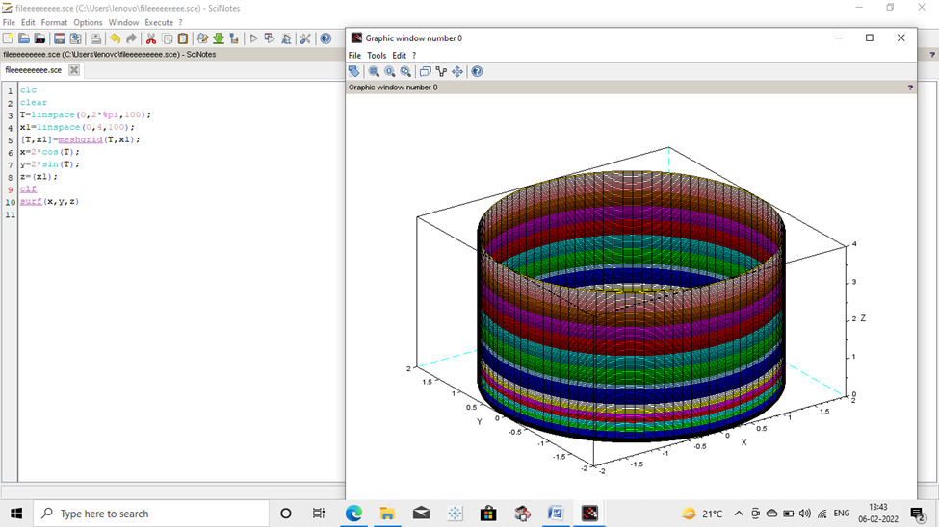

*8. To plot Sphere x2+y2+z2=a2, Take a=1*

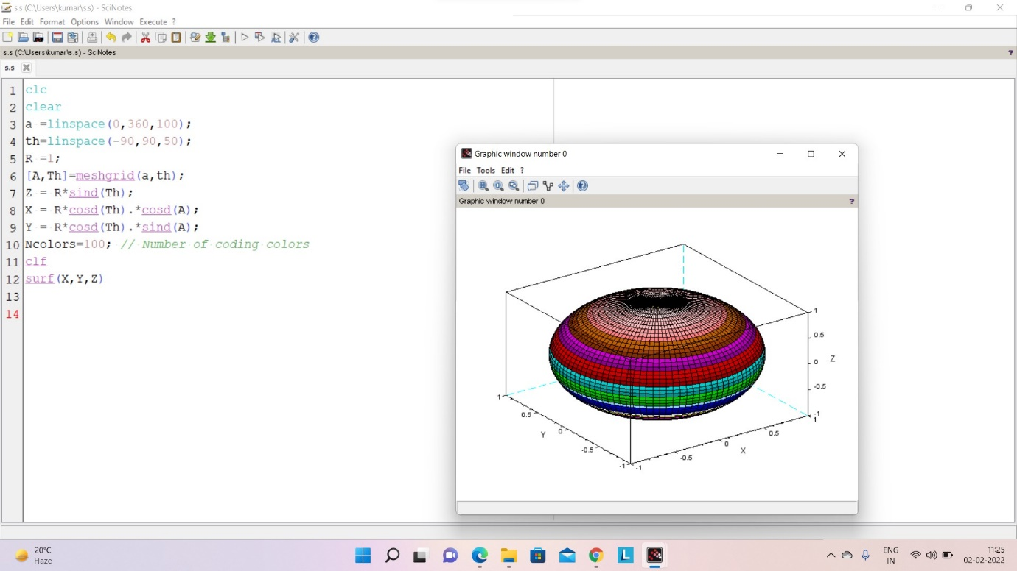

*9. To plot Ellipsoid. X2/a2 +y2/b2 + z2/c2 =1,Take a=4,b=3,c=2*

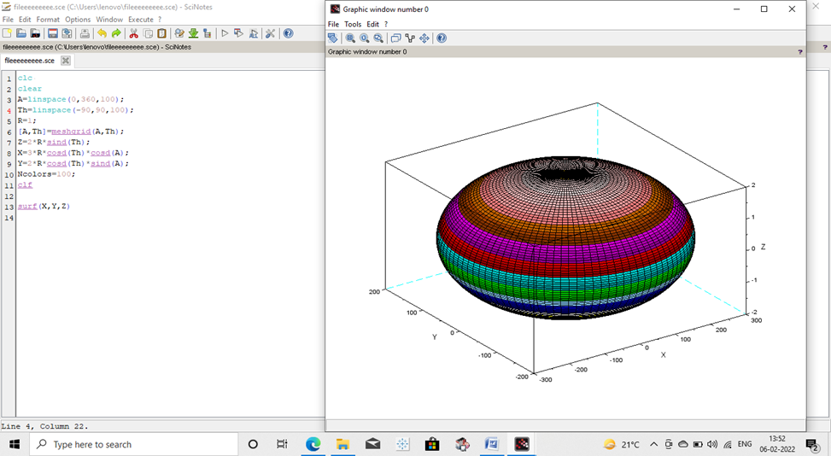

*10. To plot Hyperboloid x2/a2 +y2/b2- z2/c2 =1 . Take a=4,b=3,c=2*

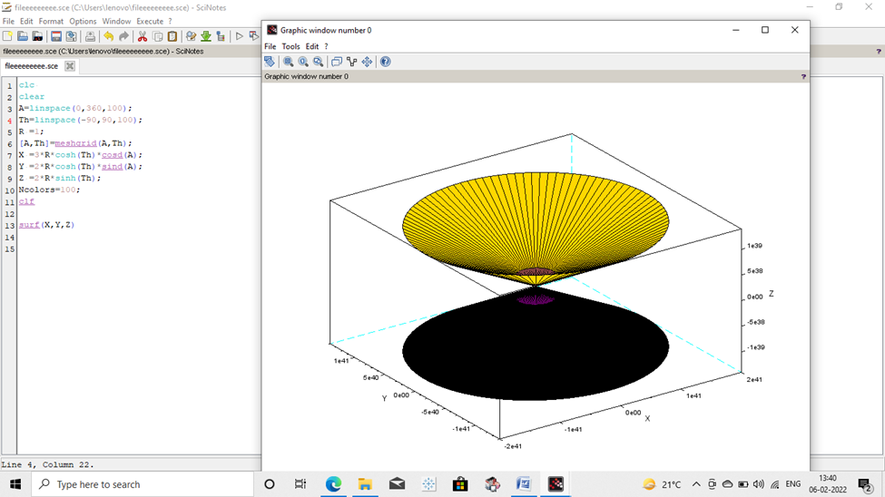

***EXPERIMENT 5***

***Objectives:***

*To write a* SCILAB -CODE

5.1. To find the error in estimated value (yest) of a function f(x) at a point x using its Taylor series.

5.2. To compare a function f(x) and its Taylor series expansion using 2d plots.

***Excercises***

**Write a Scilab code in a script file:**

5.1.1] To find the***error***in estimating the value of functionf(x)=ex at x=1 using its Taylor series expansion about origin.

5.1.2] To find the***error***in estimating the value of functionf(x)=sin(x) at x=pi/2 using its Taylor series expansion about origin.

5.2.1] To compare the function f(x)=exand its Taylor series expansion about origin by using 2d plots

5.2.2] To compare the function f(x)=sin(x)and its Taylor series expansion about origin by using 2d plots

***Solution***

***5.1.1] Input:***

clc;

clear;

a=0

x=1

y=%e^x

yest=0

n=1

for i=0:1:n

yest=yest+x^i/factorial(i)

end

disp(y)

disp(yest)

error=abs(y-yest)

disp(error)

***Output:***

2.7182818

2.

0.7182818

***5.1.2] Input:***

clc;

clear;

a=0

x=%pi/2

y=sin(x)

yest=0

n=10

for i=0:1:n

yest=yest+((-1)^i)*(x^(2*n+i)/factorial(2*n+1))

end

disp(y)

disp(yest)

error=abs(y-yest)

disp(error)

***Output:***

***1.***

***9.211D-15***

***1.0000000***

***5.2.1] Input:***

clc;

clear;

x=linspace(-10,10,100)

y=%e^x

yest=0

n=10

for I =0:1:n

yest=yest+x^i/factorial(i)

end

plot(x, y,"r")

plot(x, yest)

error=abs(y-yest)

disp(error)

***Output:***

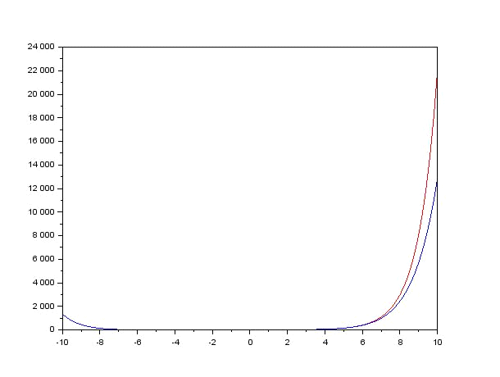

***5.2.2] Input:***

clc;

clear;

x=linspace(-%pi,%pi,100)

y=sin(x)

yest=0

n=1

for i=0:1:n

yest=yest+((-1)^i)*(x^(2*i+1)/factorial(2*i+1))

end

plot(x,y,"r")

plot(x,yest)

xtitle("Graph of sin(x).and.itstaylor series")

error=abs(y-yest)

disp(error)

***Output :***

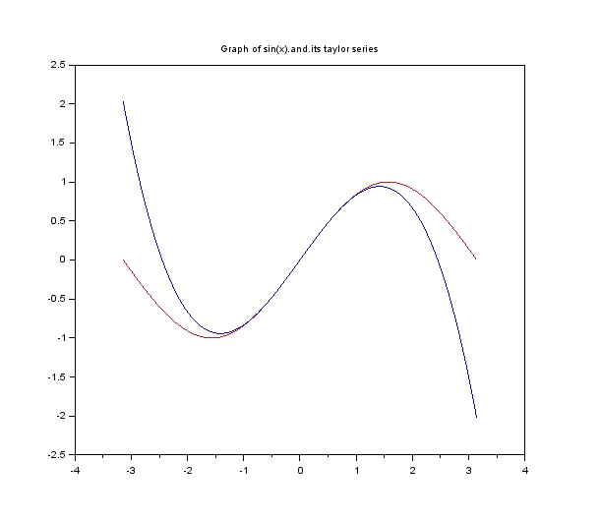

***Experiment-6***

**Write a SCILAB -CODE for Fourier Half Range series expansion of different wave forms and comparison with the original function.**

***Objectives:***

*To write a* script file

6.1. To find the **Fourier half range cosine series** of f(x) in Half-range (0, L) .

6.2. To find the **Fourier half range sine series** of f(x) in Half-range (0, L) .

6.3. To find the **Fourier series** of f(x) in (-L, L) .

**Exercises: ( All exercises to be solved on scinotes)**

6.1.1. To find the ***Fourier* coefficients**of the **Half range cosine series** of y=f(x)= x2  in (0,2) and **compare the graph** of the function and the series.

6.1.2. To find the **Fourier coefficients**of the **Half range sine series** of y=f(x)= x2  in (0,2) and **compare the graph** of the function and the series.

6.2.1. To find the ***Fourier* coefficients**of the **Half range cosine series** of

y=f(x)= x in (0, pi) and **compare the graph** of the function and the series.

6.2.2. To find the ***Fourier* coefficients** of the **Half range sine series** of y=f(x)= xin (0, pi) and **compare the graph** of the function and the series.

6.3.1. To find the ***Fourier* coefficients**of the **Fourier series** of y=f(x)= x2  in (0, 2pi) and **compare the graph** of the function and the series.

SOLUTIONS

**6.1.1**

**Source Code**

clc

clear

clf

L= input("Enput the value of L=")

n= input("Enter the valu of n=")

*//to find fourircoff a0 n an*

a0=(2/L)*integrate('x^2','x',0,L)

disp("a0",a0)

fori=1:n

a(1)=(2/L)*integrate('x^2*cos((i*%pi*x)/L)','x',0,L)

end

disp("a",a)

*//comparing the graph of funtion and its cosine series*

x=linspace(0,L,40)

y=x^2

series=a0/2

fori=1:n

series=series+a(i)*cos(i*%pi*x/L)

end

plot(x,y)

plot(x,series,"*r")

xtitle("plot function vs its fourier series by Abhinav Kumar Choudhary ","x-axis","y-axis")

legend("plot of function","plot of funtion by fourier series")

**Output**

Enput the value of L=2

Enter the valu of n=1

"a0"

2.6666667

"a"

-1.6211389

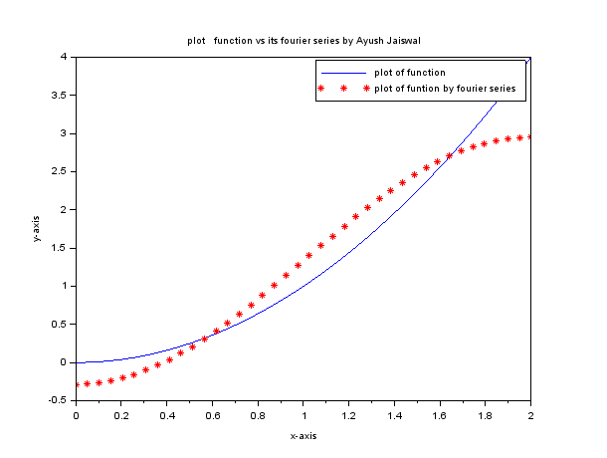

**6.1.2**

**Source Code**

clc

clear

clf

L=input("Enput the value of L=")

n=input("Enter the valu of n=")

*//to find fourircoff bn*

fori=1:n

b(i)=(2/L)*integrate('x^2*sin(i*%pi*x/L)','x',0,L)

end

disp("b",b)

*//comparing the graph of funtion and its sine series*

x=linspace(0,L,40)

y=x^2

series=0

fori=1:n

series=series+b(i)*sin(i*%pi*x/L)

end

plot(x,y)

plot(x,series,"*r")

xtitle("plot function vs its fourier series by Abhinav Kumar Choudhary]","x-axis","y-axis")

legend("plot of function","plot of funtion by fourier series")

**Output**

Enput the value of L=2

Enter the valu of n=1

"b"

1.5144300

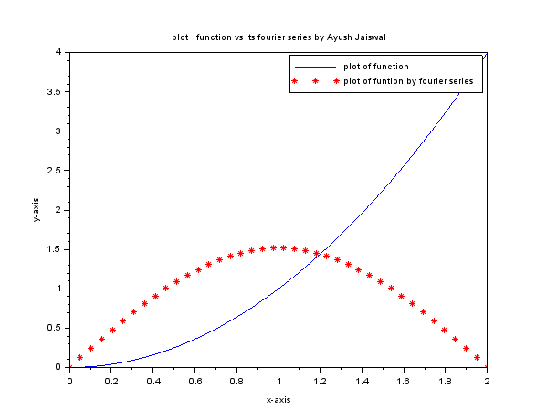

**6.2.1**

**Source Code**

clc

clear

clf

L=input("Enput the value of L=")

n=input("Enter the valu of n=")

*//to find fourircoff a0 n an*

a0=(2/L)*integrate('x','x',0,L)

disp("a0",a0)

fori=1:n

a(1)=(2/L)*integrate('x*cos((i*%pi*x)/L)','x',0,L)

end

disp("a",a)

*//comparing the graph of funtion and its cosine series*

x=linspace(0,L,40)

y=x

series=a0/2

fori=1:n

series=series+a(i)*cos(i*%pi*x/L)

end

plot(x,y)

plot(x,series,"*r")

xtitle("plot function vs its fourier series by Abhinav Kumar Choudhary","x-axis","y-axis")

legend("plot of function","plot of funtion by fourier series")

**Output**

Enput the value of L=%pi

Enter the valu of n=1

"a0"

3.1415927

"a"

-1.2732395

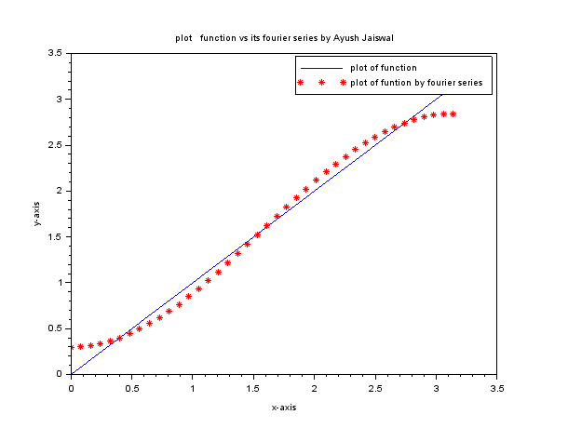

**6.2.2**

**Source Code**

clc

clear

clf

L=input("Enput the value of L=")

n=input("Enter the valu of n=")

*//to find fourircoff bn*

fori=1:n

b(i)=(2/L)*integrate('x*sin(i*%pi*x/L)','x',0,L)

end

disp("b",b)

*//comparing the graph of funtion and its sine series*

x=linspace(0,L,40)

y=x

series=0

fori=1:n

series=series+b(i)*sin(i*%pi*x/L)

end

plot(x,y)

plot(x,series,"*r")

xtitle("plot function vs its fourier series by Abhinav Kumar Chouhary","x-axis","y-axis")

legend("plot of function","plot of funtion by fourier series")

**Output**

Enput the value of L=%pi

Enter the valu of n=1

"b"

2.0000000

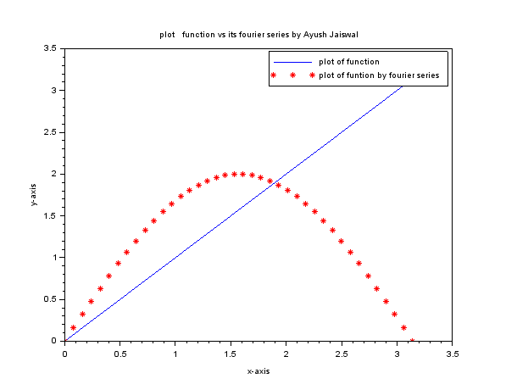

**6.3.1**

**Source Code**

clc

clear

clf

L=input("Enput the value of L=")

n=input("Enter the valu of n=")

*//To find the Fourier coefficients of the Fourier series of y=f(x)= x2*

a0=(2/L)*integrate('x^2','x',0,1)

fori=1:n

a(i)=(2/L)*integrate('(x^2)*cos(i*%pi*x/L)','x',0,1)

b(i)=(2/L)*integrate('(x^2)*sin(i*%pi*x/L)','x',0,1)

end

disp("a0",a0)

disp("a",a)

disp("b",b)

*//comparing the graph of the function and the series.*

x=linspace(0,2,40)

y=x^2

series=a0/2

fori=1:n

series=series+(a(i)*cos(i*%pi*x/L))

series=series+(b(i)*sin(i*%pi*x/L))

end

plot(x,y,)

plot(x,series,"*r")

xtitle("plot function vs its fourier series by Abhinav Kumar Choudhary","x-axis","y-axis")

legend("plot of function","plot of funtion by fourier series")

**Output**

Enput the value of L=2*%pi

Enter the value of n=1

"a0"

0.1061033

"a"

0.0982632

"b"

0.0386938

